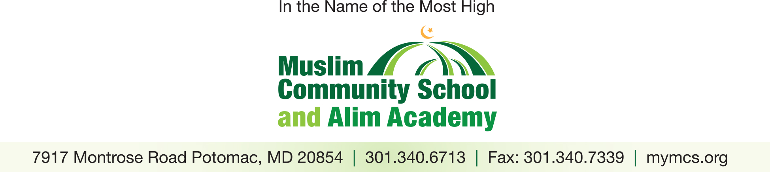

NOW HIRING FOR THE 2017-2018 ACADEMIC SCHOOL YEAR
Are you an experienced and/or licensed…
- Elementary school teacher
- Middle school teacher
- High school math or English teacher

Do the following sound appealing to you:
- Small class sizes
- Well-behaved and well-mannered students
- Teaching in a beautiful facility
- Joining a welcoming faculty
- Participating in a nonsectarian Muslim community

If you answered YES to any of the above questions, please consider applying to

The Muslim Community School (grades K – 8) and Alim Academy (grades 9 – 12)

Send a cover letter and a résumé to: principal@alimacademy.org or call 301-340-6713 for more information!

