30th Annual MCS-Alim Academy Science Fair
February 21-22, 2019
“What’s that got to do with it?”
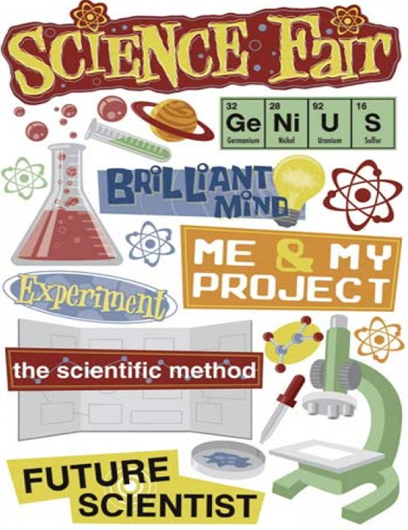

30th Annual MCS-Alim Academy Science Fair
February 21-22, 2019
“What’s that got to do with it?”

Table of Contents

Welcome Letter….….………………………….……………………………………………………….2
Science Fair Timeline Table…….………………………………………………………….………..3
Science Fair Guidelines……………………………………………………………………………….4
Science Fair Official Entry Form (Yellow sheet) ………….……………...……..………………5
Science Fair Proposal Form (Blue sheet)…..…………………………….………………...…….6
Science Fair Possible Questions Form (Pink sheet)..………..………….…..………………...7
Science Fair Parent Approval Form (Green sheet)..……………………..…..…………………8

Indeed, within the heavens and earth are signs for the believers. And in the creation of yourselves and what He disperses of moving creatures are signs for people who are certain (in faith). [45:3-4]
Dear Parents, Students, and Staff,
AsSalaamu Alaykum,
This year we celebrate the 30th annual MCS-Alim Academy Science Fair. First^{t} through 3rd grade students will do a class project presentation on Thursday, February 21, 2019, while 4th through 11th grade students will do individual projects and present their work on Friday, February 22, 2019 in the IEC auditorium. Every student in grades 1-11 is required to participate. Parents are encouraged to provide some assistance to make the science fair projects safe and help with providing an educationally rich event.
We hope that our students will learn the important role math and English play in the success of their work, therefore the math and English content of the posters will be checked for accuracy.
Students in grades 6 through 11 are highly encouraged to use their same project and participate in the Montgomery County Science Fair, which will be held on March 22 and 23, 2019 at the Food and Drug Administration White Oak Campus, 10903 New Hampshire Avenue, Silver Spring, MD 20993. The Awards Ceremony for Fair Prize Winners will be held March 24, 2019 at Montgomery Blair High School, 51 University Blvd E Silver Spring, MD 20901.
Students may enter the county fair without attaining any placement in our school Science Fair event. In fact, it is possible for a student to receive recognition from the county fair while they may not do so at the school fair. Please refer to the “rules wizard” on their website www.sciencemontgomery.org prior to starting your research to determine what is needed for each specific type of project.
For help or questions please contact or make an appointment with Sr. Mahboubeh:
- Sr. Mahboubeh Azarmnia: mazarmnia@mymcs.org

2018-19 Science Fair Time Table

 | Due date | Assignment | Initial
1 | Nov. 8 | Parental acknowledgement sheet signed (green sheet)
2 | Nov. 15 | List of possible questions (pink sheet)
3 | Dec. 6 | Science Fair proposal sheet (blue sheet)
4 | Dec. 13 | MCS official entry form (yellow sheet)
5 | Jan. 10 | Primary sample data report
6 | Jan. 24 | Completed data report
7 | Feb.  4-8 | Preliminary posters (Do not glue anything to poster)
8 | Feb.  11-15 | In class presentations
9 | Feb. 21 | K-3rd Science Fair presentations
10 | Feb. 22 | 4-11th Science Fair and Judging from  9:00 AM - 12:30 PM  Award Ceremony from 2:30 PM - 3:15 PM

2018-19 Science Fair Guidelines
In order for a student to qualify to participate in the Science Fair competition, all the required steps mentioned in the time table must be completed and turned in by the specified due dates. Failure to fulfill two of the steps (including the in-class presentation) by the given due date automatically disqualifies a student from participating in the competition. However, all steps—including the final project—are part of the “presentation and projects” grade for the second and third quarters. Therefore, if a student is disqualified from participating in the competition, he/she is still required to finish his/her project and turn them in by the specified due dates in order to get credit for the presentation and projects portion of the class grade.
Keep in mind that the scientific method must be demonstrated and the following items should be included in your poster:
- Abstract (required for middle and high school only)
- Problem/question
- Background information
- Hypothesis
- Material
- Procedure
- Observations/results
- Analysis
- Conclusion
- Future direction
- Bibliography and citation

Parents are encouraged to guide the students but should NOT be the main contributors of the project. We expect the students to display their own careful and creative work. Remember that the teachers will be available for advice, support, encouragement, motivation, and to ensure safety, as well as approve or disapprove topics or methods of research chosen by the students. The students may make arrangements with their teachers if they need to use laboratory equipment.
MCS-Alim Academy Science Fair Official Entry Form
Due date: Dec. 13th

Name: ……………………………………………………………………………………………
Grade: ……………………………………………………………………………………………
Project title: ………………………………………………………………………………….

Project area (check one):
- Chemistry
- Biology
- Physics
- Mathematical behavioral science
- Other (specify)…………………………………………………………………………..
Will you require electricity for your project display?
- Yes
- No
MCS-Alim Academy Science Fair Proposal Form
Due date: Dec. 6th

Name: ……………………………………………………… Grade: …………………..
Answers to the following questions must be TYPED on a SEPARATE sheet stapled to this sheet.
- Topic: what is the title of your project?
- Research question: what question do you want to answer by working on your project?
- Background information: what information can you provide to explain why this is important to study?
- Hypothesis: what is your educated guess, or what do you think would be the result of this experiment based on the information you have collected?
- Materials: what would you need to perform this experiment?
- Controls: what do you think should be the control for this experiment?
- Dependent variable: what is it that you are measuring, recording, or counting?
- Independent variable: what are you changing deliberately during the experiment that would cause an effect that is measurable?
- Procedure: what are the steps you will need to take in order to perform this experiment? You may draw a sketch to further clarify.
Science Fair List of Possible Questions/Problems
Due date: Nov. 15th

Name: …………………………………………………… Grade: …………………..
Attention:
- If neither of your choices get accepted by your instructor, please list at least two new/revised questions or topics and return within one week.
- If more than one choice was accepted by your instructor, please circle the finalized question or topic you have chosen for your project and return within one week.
First possible question/problem:

Second possible question/problem:

Third possible question/problem:

MCS-Alim Academy Science Fair Parent Acknowledgement Form
Due date: Nov. 8th

I have read and discussed the Science Fair packet with my child. I understand that many of the instructions and guidelines are not included in this package and they could be found on the supplementary package (sent via email and the link provided on the school website: http://www.mymcs.org/)

Comment:

Student’s Name …………………………………….……………….
Student’s Signature …………………………….…………………. Date: ……………..

Parent/Guardian’s Name ………………………..…………………
Parent/Guardian’s Signature …………………………………….. Date: …………..…

